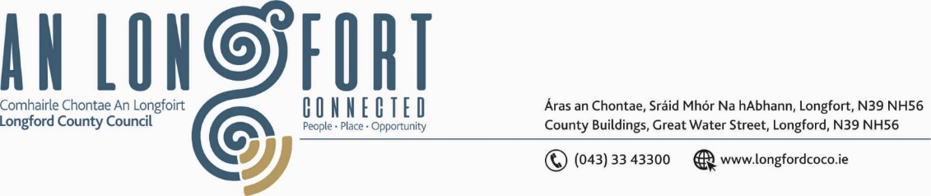

***BALLYMAHON MUNICIPAL DISTRICT***

***Please note meeting will be held via Microsoft Teams and in Ballymahon Library.***

**22 July 2022.**

**To: Each Member of Ballymahon Municipal District.**

**Dear Member,**

You are requested to attend a Meeting of Ballymahon Municipal District to be held

**in Ballymahon Library and via Microsoft Teams** on **Thursday 28 July 2022 at 4.30pm** to transact business, as set out on the agenda hereunder.

**Yours sincerely**,

Ann Marie Mc Keon

_______________

**Ann Marie Mc Keon,**

**Meetings Administrator.**

**AGENDA**

Prayer before meeting.

**1.** Confirmation of Minutes:

(i) Ballymahon Municipal District Meeting held on the 23 May 2022 – copy enclosed.

(ii) Ballymahon Municipal District Committee Meeting held on the 23 May 2022 – copy enclosed.

(iii) Ballymahon Municipal District Annual General Meeting held on 29 June 2022 – copy

Enclosed.

**2.** Matters arising from Minutes.

**3.** Declaration of Interest by Members.

**4.** Management Report - enclosed.

**5.** Community Grant Support Scheme 2022 – enclosed.

**6.** Consideration of time for next meeting.

**7. Notices of Motions, submitted by Councillors, as listed hereunder –**

**Councillor Paul Ross**

(i) That a pedestrian crossing be installed at the Bracklyn Road / Park House Hotel junction in Edgeworthstown in the interest of public safety.

(ii) “I call on Longford County Council to install public lighting on the footpath outside Ballycloughan Hall in the interests of public safety.”

(iii) I call on Longford County Council to replace the footpaths in Devine Crescent from houses 1 to 12 which are in very poor repair and are dangerous to the members of the community who live in these houses.

**Councillor Pat O’Toole**

(i) I call on Irish Water to replace the water supply pipes on the N55 from Ballymahon to Carrickboy as a matter of urgency.

(ii) I call on Longford County Council to consider a Low-Cost Safety Scheme on the L52341 at Darogue Ballymahon to improve the sight lines and in the interest of public safety.

(iii) I call on Longford County Council to erect a mesh wire fence along the boundary of

the Ballymahon 1916 Commemorative Garden and the Inny River in the interest of

public safety. The current timber post and rail fence is in poor condition and unsafe.

**Councillor Mick Cahill**

(i) I propose that Longford County Council provide adequate energy efficient public lighting in front the Recently Refurbished Community facility in Ballycloghan in the interest of public safety.

(ii) Why is there an increasing number of Water Bursts in the Ballymahon water supply. This is causing a lot of a anxiety and disruption for domestic, business and farming users. Are there any plans to upgrade the pipe network and what is the procedure for members of the public to report leaks?